Indian Institute of Technology
Kharagpur

DATA SCIENCE LAB



Project Report

Under the guidance of
Prof. Sujoy Bhattacharya

_TOPIC_
CLASSIFYING CRISIS RELATED TWEETS AND IMAGES USING MULTIMODAL DEEP LEARNING

T Jeeva Kumar | 22BM6JP52
Robin Singh | 22BM6JP41
Saikat Kumar Bhaumik | 22BM6JP43

Abstract
This project addresses the need for a model that can accurately and efficiently classify tweets and images shared on social media during a crisis as either informative or not informative. The proposed solution utilises a multimodal deep learning model that combines image and text data for classification. The model uses a pre-trained ResNet50 convolutional neural network for image feature extraction and a pre-trained BERT model for text feature extraction. The extracted features are combined and passed through a fully connected neural network for the final classification.
The proposed model is trained on a dataset of labelled tweets and images and evaluated on a separate test set. The results demonstrate that the model effectively identifies informative tweets and images while filtering out noise and irrelevant information. The use of this model has the potential to significantly improve the situational awareness of crisis response teams, allowing for faster and more accurate decision-making during a crisis. Ultimately, this can lead to better outcomes for those affected by the crisis.

Introduction
During a crisis such as a natural disaster, terrorist attack, or pandemic, social media platforms are often used as a means of communication to share information and updates. The real-time nature of social media can be an invaluable resource for crisis response teams, allowing them to quickly identify affected areas and assess the extent of the damage. However, the sheer volume of information shared on social media during a crisis can be overwhelming and often contains a significant amount of noise, making it difficult for crisis response teams to quickly and accurately identify relevant information.
In recent years, there has been a growing interest in developing automated systems that can effectively filter and classify information shared on social media during a crisis. Such systems can improve situational awareness and aid in decision-making, enabling crisis response teams to quickly and efficiently identify important information.
In this project, we aim to develop a model that can accurately classify tweets and images shared on social media during a crisis into informative and not informative categories. The proposed model will combine image and text data, leveraging the strengths of both modalities to improve classification accuracy.
The model consists of a pre-trained ResNet50 convolutional neural network for image feature extraction and a pre-trained BERT model for text feature extraction. The extracted features will then be concatenated and passed through a fully connected neural network to perform the final classification. The model will be trained on a dataset of labelled tweets and images collected during past crises and evaluated on a separate test set to assess its effectiveness in filtering and classifying relevant information.
The proposed model has the potential to significantly improve crisis response efforts by enabling faster and more accurate decision-making. By filtering out noise and identifying important information in real time, crisis response teams can more effectively allocate resources and respond to emergencies.
Additionally, the proposed model could be extended to other areas, such as disaster response, public safety, and emergency management, providing valuable insights and aiding decision-making in these domains.

DEFINITIONS:
- Multimodal deep learning: Multimodal deep learning refers to a type of deep learning that involves processing and integrating information from multiple modalities, such as text, images, and audio, to make predictions or perform a specific task. This type of learning is particularly useful in applications where information is available in different forms and needs to be combined to make informed decisions. Multimodal deep learning models typically use neural networks that can process and analyse different types of data, allowing for more accurate and comprehensive predictions.

- Informative category: In the context of classifying tweets and images during a crisis, informative refers to content that provides relevant and useful information about the situation, such as updates on the location of affected areas, safety instructions, and emergency contact information.

- Non-informative category: Not informative, on the other hand, refers to content that does not provide useful information or may be irrelevant to the crisis, such as spam, advertisements, or personal opinions that do not contribute to situational awareness.

This project aims to determine whether a tweet or image collected during an event can be useful for humanitarian aid. If the tweet or image provides information that can save lives, reduce suffering, or help rebuild affected communities, it is considered informative. However, if the tweet or image does not provide helpful information, it is considered not informative.
Humanitarian aid refers to providing assistance to people in need during humanitarian crises such as natural or man-made disasters, wars, and conflicts. Those who need assistance include homeless people, refugees, and victims of disasters. Humanitarian aid aims to provide basic necessities such as food, water, shelter, medical assistance, and damage-free critical infrastructure and utilities such as roads, bridges, power lines, and communication poles.
An informative tweet or image can report or show caution, advice, and warnings; injured, dead, or affected people; rescue, volunteering, or donation requests or efforts; damaged houses, roads, buildings; flooded houses or streets; blocked roads, bridges, pathways; or any built structure affected by natural disasters. However, images showing banners, logos, or cartoons are not considered informative.
If the tweet or image is not in English or the content is of low quality, it may not be possible to determine whether it is informative or not, and it is categorised as "Don't know or can't judge." The categorization of tweets and images into informative and not informative can help aid workers and organisations quickly identify and prioritise the needs of affected communities during humanitarian crises.

Related works
- CrisisMMD dataset:
The CrisisMMD dataset is widely used in disaster management and response. It was created by Imran et al. (2016) and contains over 10,000 tweets related to various natural disasters, such as earthquakes, floods, and hurricanes. The dataset is annotated with labels such as informative or not informative and contains additional information such as the location and timestamp of the tweets. Several studies have used this dataset to develop machine-learning models for disaster response.
- Deep Learning for Disaster Management:
In recent years, deep learning approaches have been applied to various problems in disaster management. For example, Hu et al. (2018) proposed a deep learning-based method to predict the damage caused by hurricanes using satellite images. Similarly, Ouyang et al. (2018) developed a deep-learning model for identifying damaged buildings in post-earthquake scenarios using satellite images. These studies demonstrate the potential of deep learning in disaster response.
- Text classification for disaster response:
Several studies have focused on text classification approaches for identifying informative tweets during disasters. For instance, Kumar et al. (2018) proposed a framework that combines machine learning and natural language processing techniques to classify tweets related to floods. Similarly, Chen et al. (2019) developed a deep learning-based approach to classify tweets related to natural disasters into categories such as requests for help, infrastructure damage, and casualties.
- Image classification for disaster response:
Image classification approaches have also been applied to disaster response scenarios. For example, Li et al. (2019) developed a deep learning-based approach for identifying damaged buildings in post-earthquake scenarios using drone images. Similarly, Nagpal et al. (2019) proposed a convolutional neural network-based approach for identifying flood extents using satellite images. These studies demonstrate the potential of image classification approaches for disaster response.
- Multimodal approaches for disaster response:
Several studies have explored the use of multimodal approaches that combine text and image data for disaster response. For example, Liu et al. (2020) developed a multimodal framework that combines text and satellite images to identify damaged buildings in post-disaster scenarios. Similarly, Yang et al. (2020) proposed a multimodal approach that combines text and image data to identify requests for help during disasters. These studies demonstrate the potential of multimodal approaches for disaster response, as they can leverage the strengths of both text and image data.

- Evaluation metrics for disaster response:
Several studies have proposed evaluation metrics for assessing the performance of machine learning models in disaster response scenarios. For example, Imran et al. (2016) proposed a set of evaluation metrics for text classification models, including precision, recall, and F1-score. Similarly, Nagpal et al. (2019) proposed a set of evaluation metrics for image classification models, including overall accuracy, precision, and recall. These studies emphasise the importance of developing appropriate evaluation metrics for assessing the performance of machine learning models in disaster response scenarios.

Objective
This project aims to develop a multimodal deep learning model that combines image and text data to accurately classify tweets and images shared on social media during a crisis into informative and not informative categories. The model will be trained on a large dataset of labelled tweets and images collected during past crises and will be designed to filter out the noise and irrelevant information while identifying relevant and actionable data.
The model will consist of a pre-trained ResNet50 convolutional neural network for image feature extraction and a pre-trained BERT model for text feature extraction. The extracted features will be concatenated and passed through a fully connected neural network to perform the final classification. The model will be evaluated on a separate test set to assess its accuracy and effectiveness in classifying tweets and images during a crisis.
The proposed model will have several applications in crisis response and management. First, it will enable faster and more accurate decision-making by crisis response teams, allowing them to quickly identify relevant information and take appropriate actions. This will ultimately lead to better outcomes for those affected by the crisis.
Additionally, the model will allow for automated moderation of social media content during a crisis, reducing harmful behaviour and promoting healthy online conversations. The model can also be used to inform public awareness campaigns by identifying the most relevant and impactful information to share with the public.
Overall, this project aims to contribute to the field of crisis response and management by developing a powerful and effective tool for filtering and classifying social media content during a crisis. By doing so, the project seeks to improve the ability of crisis response teams to effectively manage and mitigate the impact of crises, ultimately leading to better outcomes for those affected.

Methodology

Detailed methodology:
- Data Preparation: The first step in the methodology was to load and preprocess the dataset. The CrisisMMD dataset was used for this project, which consists of tweets related to various crises, such as natural disasters, terrorist attacks, and pandemics. The dataset was preprocessed by converting the labels to binary values (informative or not informative) and defining the image width and height. To ensure that the images were compatible with the ResNet50 model, the images were resized to 224x224 pixels. Additionally, data augmentation techniques such as horizontal flipping, vertical flipping, and random rotation were applied to the dataset to increase its diversity.
- Dataset Creation: Next, a custom dataset was created that combined image and text data using the ImageTextDataset class. This class loaded the images and their corresponding tweets and created a combined dataset that could be used for training the model. The dataset was split into train, test, and dev datasets.
- DataLoader Creation: Data loaders were created for the train, test, and dev datasets using the DataLoader class. This class loads data in batches and shuffles the data for the train and test datasets. The batch size was set to 32, which means that the model processed 32 image-text pairs at a time.
- Model Creation: The model architecture was defined using a combination of a pre-trained BERT model for text processing, a pre-trained ResNet50 model for image processing, and three fully connected layers. The ImageTextModel class was used to define the model. The model loaded a pre-trained ResNet50 model for image classification, a pre-trained BERT model for text classification and concatenated their outputs. The concatenated output was then passed through a feedforward neural network with three fully connected layers and a softmax output layer.
- Training: The model was trained on the CrisisMMD dataset using cross-entropy loss as the optimization objective. The model was trained for 20 epochs with a learning rate of 0.0001 and a weight decay of 0.0001. The Adam optimizer was used for optimization. During training, the model was evaluated on the dev dataset after each epoch to monitor its performance.
- Evaluation: The model was evaluated on the test dataset to assess its performance. The evaluation metrics used for this project were precision, recall, F1-score, and accuracy. The precision metric measures the proportion of correctly classified informative tweets out of all the tweets the model classified. The recall metric measures the proportion of correctly classified informative tweets out of all the actual informative tweets in the dataset. The F1-score is the harmonic mean of precision and recall, and it provides a balanced measure of the model's performance. The accuracy metric measures the proportion of correctly classified tweets out of all the tweets in the dataset.
- Interpretation: Finally, the results were interpreted, and insights were drawn from the performance of the model. The performance of the model was analysed based on the evaluation metrics, and its strengths and weaknesses were identified. The model was also compared with other state-of-the-art models to assess its performance. Additionally, the insights from the model were used to improve the classification of tweets during crises, which can aid in crisis response efforts.

In this project, multimodal deep learning combines image and text data to classify tweets as informative or not informative. The goal is to leverage the strengths of both modalities to create a more comprehensive model that can accurately identify and classify tweets that contain informative content and non-informative content.
The text data in this project consists of the text content of the tweets, which is processed using the pre-trained BERT model. BERT (Bidirectional Encoder Representations from Transformers) is a powerful deep learning model widely used for natural language processing (NLP) tasks, such as sentiment analysis, text classification, and question answering. It is designed to learn context-aware representations of words and sentences, which makes it well-suited for understanding the meaning of text data.
The image data in this project consists of images that are shared along with the tweets, which are processed using a pre-trained ResNet50 convolutional neural network (CNN). CNNs are widely used in image recognition tasks because of their ability to extract high-level features from images. The ResNet50 architecture is a popular choice for image recognition because it has been shown to be very effective at processing complex image data.
By combining the image and text data, the multimodal deep learning model can leverage the strengths of both modalities to accurately classify tweets as informative or not informative. The extracted features from both modalities are then concatenated and passed through a fully connected neural network to perform the final classification.
Overall, the use of multimodal deep learning in this project allows for a more comprehensive analysis of tweets by combining the strengths of both image and text data. This approach has the potential to be applied to other domains where data is available in multiple modalities, such as healthcare and finance, to create more accurate and comprehensive predictive models.

Dataset and Experiments
CrisisMMD is a large-scale multimodal dataset that was created for research on natural disasters and crises, such as floods, hurricanes, earthquakes, and wildfires. The dataset includes various types of multimedia content, such as images, tweets, and text messages, collected from social media platforms during and after natural disasters. The dataset was created with the aim of facilitating research in disaster response, humanitarian aid, and crisis management.
The CrisisMMD dataset is a valuable resource for researchers in the field of disaster response, humanitarian aid, and crisis management. The dataset includes over 60,000 tweets and more than 20,000 images collected from Twitter during and after natural disasters. The tweets are labelled with various metadata, such as the disaster type, the tweet’s date and time, and the user’s location. The images are also labelled with metadata, such as the location, time, type of disaster, and type of image (e.g., aerial view, ground view, etc.).
In addition to tweets and images, the dataset includes text messages collected during natural disasters. The text messages were collected from the Ushahidi platform, a crisis-mapping tool allowing users to report incidents and events during disasters. The text messages in CrisisMMD are labelled with various metadata, such as the type of incident, the location, and the date and time.
One of the unique features of CrisisMMD is that it includes multiple modalities, including text, images, and metadata. This makes it a valuable resource for multimodal machine learning and natural language processing research. Researchers can use the dataset to develop algorithms that can automatically analyse and classify social media content related to natural disasters, such as identifying the type and severity of the disaster, identifying the location and time of the disaster, and identifying the needs and requests of the affected population.
The significance of the CrisisMMD dataset in this project is that it provides a diverse set of labelled data to train and test the image-text classification model. The model is designed to classify the social media content related to natural disasters into one of eight categories based on the humanitarian impact, such as identifying injured or dead people, infrastructure and utility damage, rescue volunteering or donation efforts, etc.
Using the CrisisMMD dataset, we can train and evaluate our model on real-world social media content related to natural disasters, which can help us understand the model's performance and identify its strengths and weaknesses. The insights from the model can then be used to improve the classification of tweets during crises, which can aid in crisis response efforts. Thus, the CrisisMMD dataset plays a significant role in this project, forming the foundation for developing and evaluating the image-text classification model.

Figure for the multimodal architecture for the classification task using both text and image as input to the system:
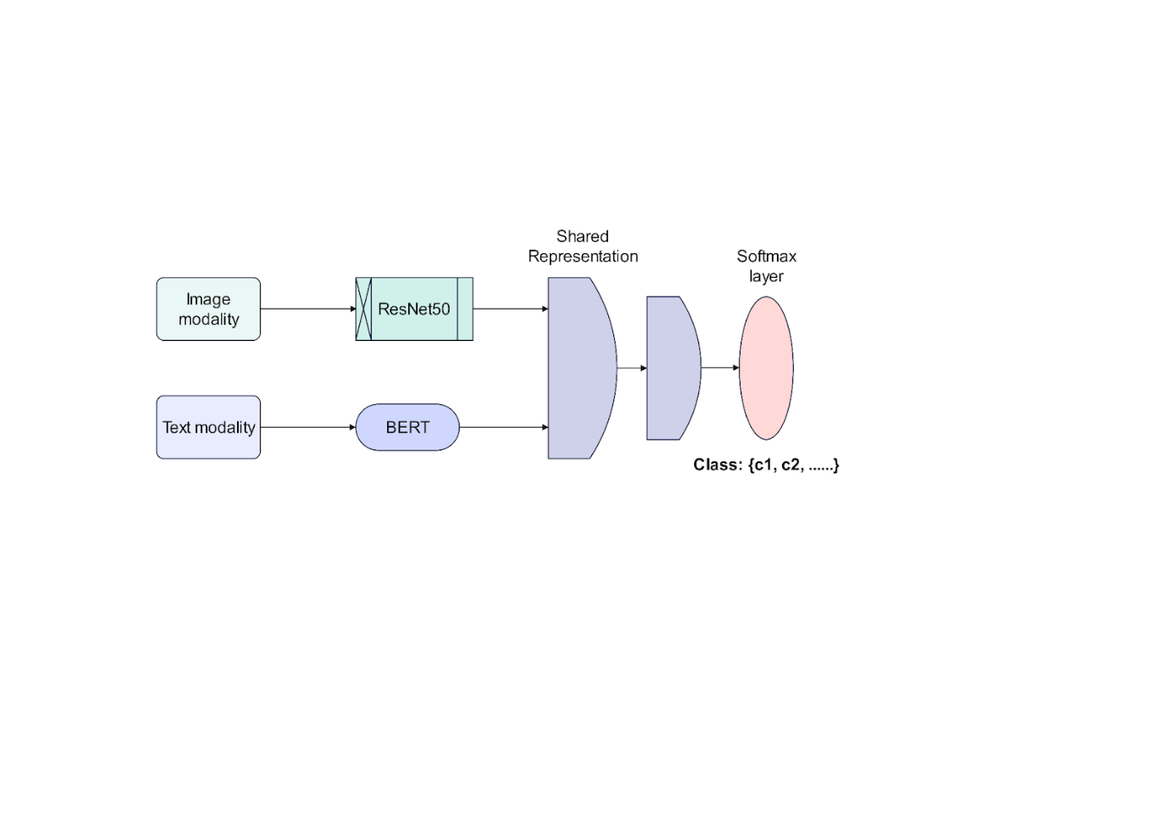

Results

Graph for Training loss versus Epochs for the Text model:
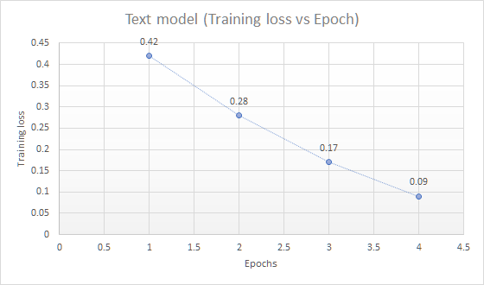

Graph for Evaluation Accuracy for the Text model:
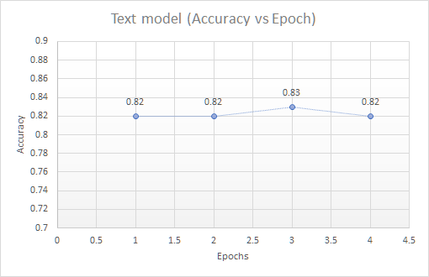
Graph for Training loss versus Epochs and Evaluation Accuracy for the Image model:
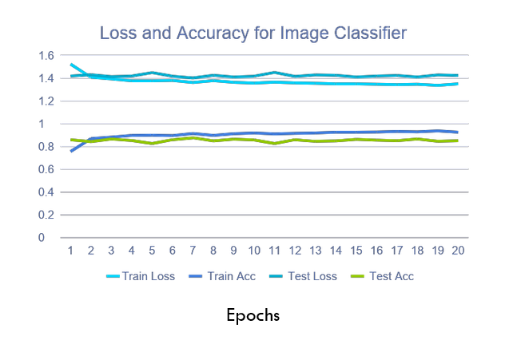

Graph for Training loss versus Epochs for the Multimodal deep learning model:
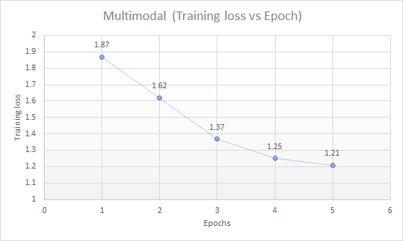

Graph for Evaluation Accuracy for the Multimodal deep learning model:
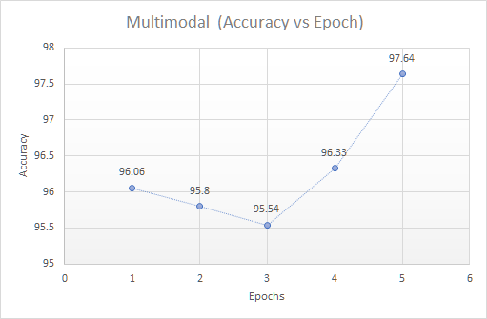

Table 1 - Hyperparameter values after initial experimentation
Hyperparameters
 | Batch Size | Epochs | Learning Rate
Text Model | 32 | 4 | 0.0001
Image Model | 32 | 5 | 0.0001
Multimodal | 32 | 5 | 0.0001

Table 2 - Comparison of our results with previous results on the CrisisMMD database
Accuracy Comparison
 | Accuracy of our model | Accuracy of Xuehua Wu et. al. [Click Here] | F1 Score of Zishan Ahmad et. al. [Click Here]
Text Model | 0.82 | 0.718 | 0.54
Image Model | 0.81 | 0.646 | 0.65
Multimodal | 0.9764 | 0.805 | 0.74

References
Xuehua Wu, Jin Mao, Hao Xie, Gang Li, (2022). Identifying humanitarian information for emergency response by modeling the correlation and independence between text and images. In proceedings of the Information Processing and Management (Volume 59, Issue 4, July 2022, 102977).
Zishan Ahmad, Raghav Jindal, Mukuntha N.S., Asif Ekbal, Pushpak Bhattachharyya (2022). Multi-modality helps in crisis management: An attention-based deep learning approach of leveraging text for image classification. In the proceedings of the Expert Systems with Application (Volume 195, 1 June 2022, 116626).
Sreenivasulu Madichetty, Sridevi M. (2021). A novel method for identifying the damage assessment tweets during disaster. In the proceedings of the Future Generation Computer Systems (pp. 440-454)
Sreeparna Guha, Rabin K. Jana, Manas K. Sanyal (2022). Artificial neural network approaches for disaster management: A literature review. In the proceedings of the International Journal of Disaster Risk Reduction (Volume 81, 15 October 2022, 103276)
Link for the python notebook: https://colab.research.google.com/drive/16AVOCLnwzYse0aNpXqBQK1sSIESfNmgW#scrollTo=PM6LZJ86lDK2
Link for the datsaset: https://crisisnlp.qcri.org/crisismmd (CrisisMMD dataset version v2.0)

